**Node.js Basics**

1. Node.js is a server-side platform built on Google Chrome's JavaScript Engine (V8 Engine). Node.js was developed by Ryan Dahl in 2009 and its latest version is v0.10.36
2. **Definition of Node.js** supplied by **official documentation** as follows:  
   Node.js is a platform built on [Chrome's JavaScript runtime](https://code.google.com/p/v8/) for easily building fast and scalable network applications. Node.js uses an event-driven, non-blocking I/O model that makes it lightweight and efficient, perfect for data-intensive real-time applications that run across distributed devices.
3. Node.js = Runtime Environment + JavaScript Library
4. Features of Node.js as follows:

* **Asynchronous and Event Driven** − All APIs of Node.js library are asynchronous, that is, non-blocking. It essentially means a Node.js based server never waits for an API to return data. The server moves to the next API after calling it and a notification mechanism of Events of Node.js helps the server to get a response from the previous API call.
* **Very Fast** − Being built on Google Chrome's V8 JavaScript Engine, Node.js library is very fast in code execution.
* **Single Threaded but Highly Scalable** − Node.js uses a single threaded model with event looping. Event mechanism helps the server to respond in a non-blocking way and makes the server highly scalable as opposed to traditional servers which create limited threads to handle requests. Node.js uses a single threaded program and the same program can provide service to a much larger number of requests than traditional servers like Apache HTTP Server.
* **No Buffering** − Node.js applications never buffer any data. These applications simply output the data in chunks.
* **License** − Node.js is released under the [MIT license](https://raw.githubusercontent.com/joyent/node/v0.12.0/LICENSE)

1. Concepts: Parts of Node.js

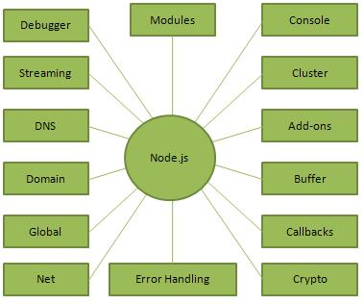

1. Who uses Node.js ?  
   This list includes eBay, General Electric, GoDaddy, Microsoft, PayPal, Uber, Wikipins, Yahoo!
2. Where to use Node.js ?

* I/O bound Applications
* Data Streaming Applications
* Data Intensive Real-time Applications (DIRT)
* JSON APIs based Applications
* Single Page applications

1. Where not to use Node.js?

It Is not advisable to use Node.js for CPU intensive applications.

1. By using **node-persis**t npm package   
   **node**-**persist** is an npm package that we can easily use in our project by executing the command: $ npm install **node**-**persist**. **node**-**persist** is a super-easy asynchronous persistent data structures in **Node**.js, modeled after HTML5 localStorage. **Node**-**persist** doesn't use a database.  
   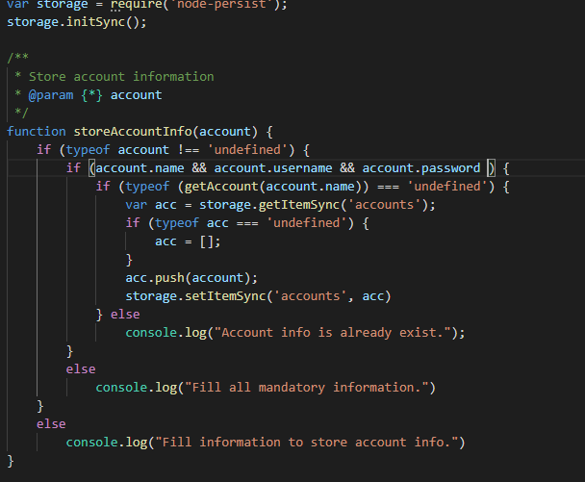

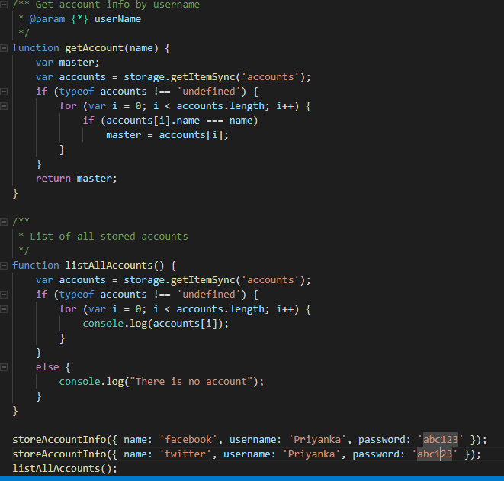

1. For command line argument, we can use **yargs** npm package with node-persist package.

**Yargs** helps us build interactive command line tools, by parsing arguments and generating an elegant user interface. It gives us: commands and (grouped) options ( node arg-using-yargs.js create –an Facebook –un Priyanka –pwd abc123). a dynamically generated help menu based on your arguments.

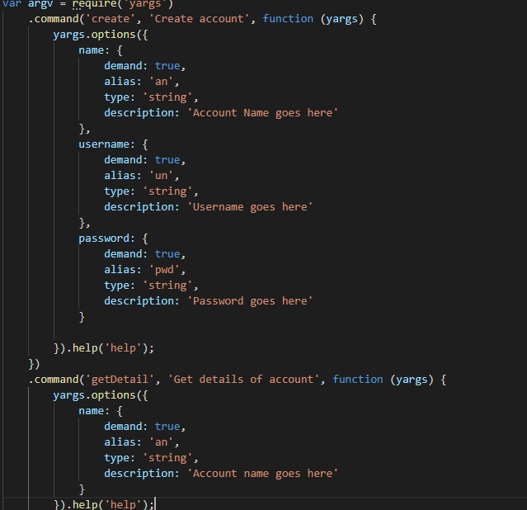

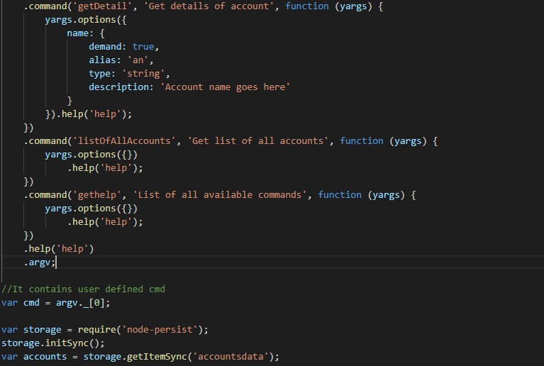

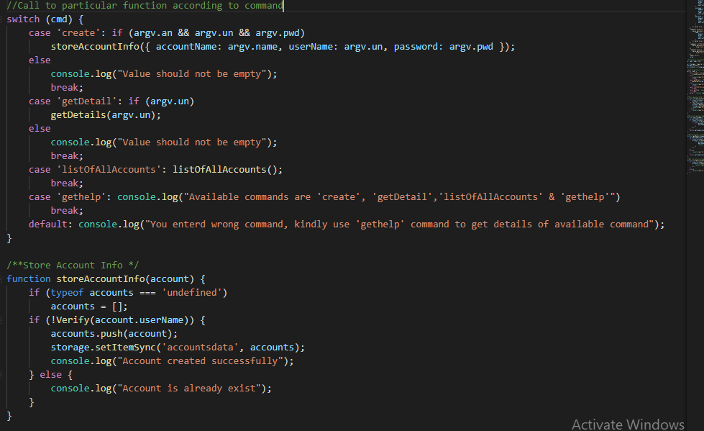

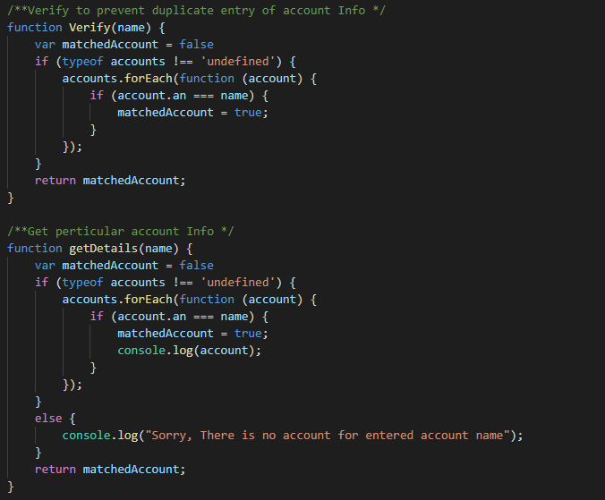

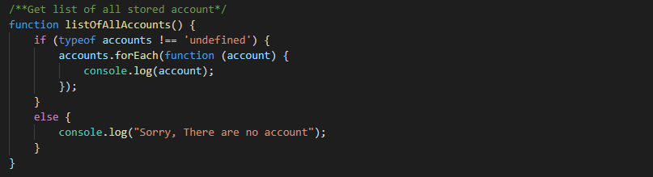

1. For encryption & decryption purpose, we can use **crypto-js** npm package.  
   **CryptoJS** is a growing collection of standard and secure cryptographic algorithms implemented in **JavaScript** using best practices and patterns. They are fast, and they have a consistent and simple interface

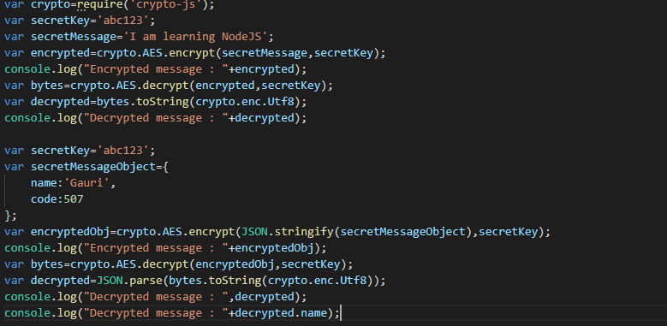

1. For Error handling, we can use try-catch block.  
   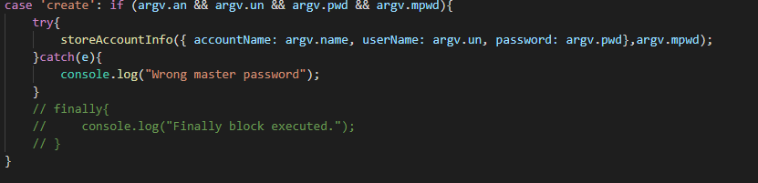
2. By using all these concepts, I have developed **password-manager application** in Node.js
3. Asynchronous programming  
   In that I have learnt callback function to execute code as per requirement & develop weather application to fetch weather information using location & location by command line argument or <https://ipinfo.io/> using system’s IP addres.

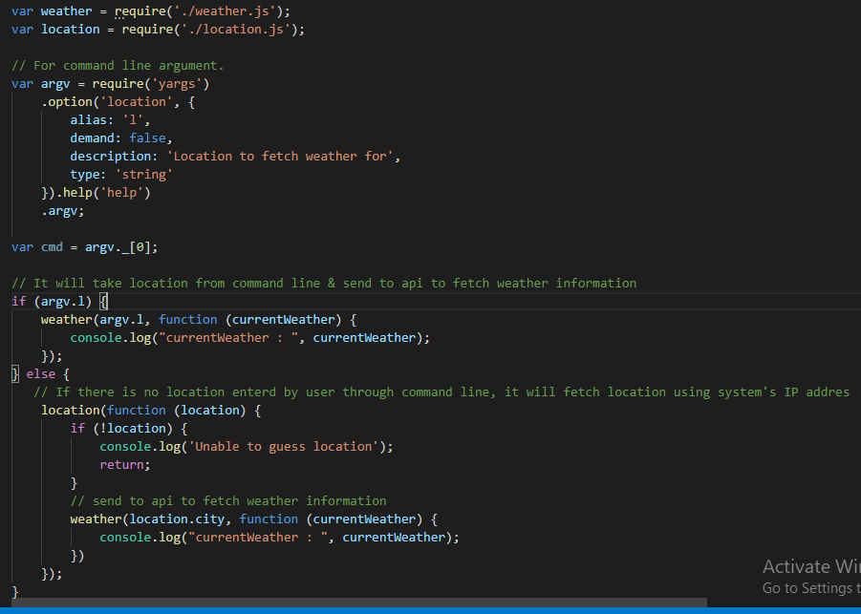weather.js  
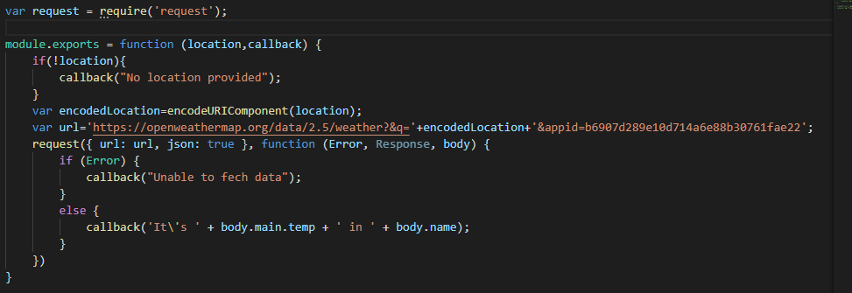location.js

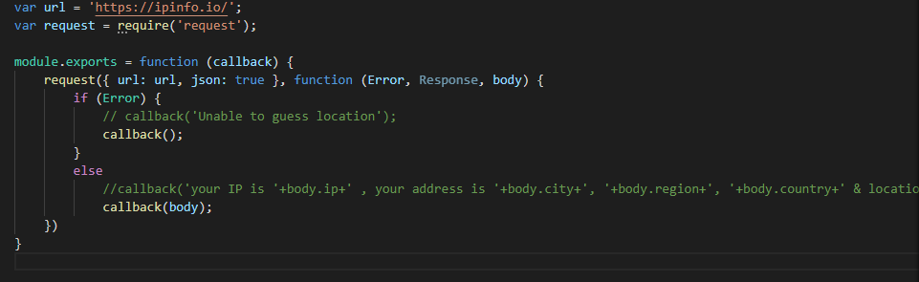

To learn this, I have used [https://www.tutorialspoint.com](https://www.tutorialspoint.com/) for Node.js notes & [https://www.udemy.com](https://www.udemy.com/) for Node.js Video Tutorials.

* Gauri Bane  
  Software Developer